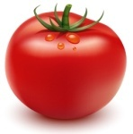  Tomato Jam  Autumn 2018  Best with fine cheese, grilled chicken  or toasted rustic bread  D. | 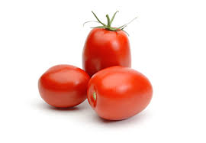  Tomato Jam  Autumn 2018  Best with fine cheese, grilled chicken  or toasted rustic bread.

Spicy

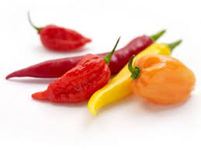
Tomato Jam

September 2018

Spicy

Tomato Jam

September 2018

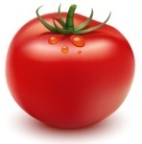
Tomato Jam

September 2018

Best with fine cheese, grilled chicken or toasted rustic bread

Tomato Jam

September 2018

Best with fine cheese, grilled chicken or toasted rustic bread

Best with fine cheese, grilled chicken

or toasted rustic bread

Best with fine cheese, grilled chicken

or toasted rustic bread

